NANOSCIENCE FOR SUSTAINABLE TECHNOLOGIES: A PATH TO A GREENER FUTURE



**PROF. RAJENDRA SINGH (RAJJU BHAIYA) UNIVERSITY, PRAYAGRAJ**

**HEMAWATI NANDAN BAHUGUNA GOVERNMENT POST GRADUATE COLLEGE, NAINI-PRAYAGRAJ**

DISSERTATION SUBMITTED FOR THE AWARD OF MASTER OF SCIENCE

IN PHYSICS

2024-25

UNDER THE SUPERVISION OF SUBMITTED BY

AASHIT JAISWAL SAMIKSHA PANDEY

M.SC. IV-SEMESTER



DEPARTMENT OF PHYSICS

IN PARTIAL FULFILLMENT OF THE REQUIREMENT FOR THE DEGREE OF MASTER OF SCIENCE IN PHYSICS

**Certificate**

It is certified that the work included in the Project entitled, “**Nanoscience For Sustainable Technologies: A Path To A Greener Future”,** submitted by **Samiksha Pandey,** for the degree of “ Master of Science (Physics)” was carried out under my direction and supervision, in the Department of Physics, Hemawati Nandan Bahuguna Government Post Graduate College, Naini-Prayagraj.

Aashit Jaiswal

Department of Physics,

Hemwati Nandan Bahuguna

Government P.G. College

Naini-Prayagraj

**Declaration**

I Samiksha Pandey, hereby declare that this submission is my own work and that the best of my knowledge and belief, it contains no material previously published or written by another person nor material which to a substantial extent has been accepted for the award in Hemawati Nandan Bahuguna Government Post Graduate College, Naini-Prayagraj or in other institution.

Samiksha Pandey

M.Sc. Physics

IV Semester

**CONTENTS**

|  |  |  |
| --- | --- | --- |
| **Chapter No.** | **Particulars** | **Page No.** |
| 1 | Introduction | 1-2 |
| 2 | Classification of Nanomaterials | 2-7 |
| 3 | Applications of Nanomaterials | 8-13 |
| 4 | Synthesis of Nanomaterials | 13-21 |
| 5 | Characterization of Nanomaterials | 22-30 |
| 6 | Nanoscience for Sustainable Technologies | 30-45 |
| 7 | Conclusion | 46-47 |
| 8 | References | 48- |

**Abstract**

The world is facing great challenges in meeting rising demands for basic commodities (e.g., food, water and energy), finished goods (e.g., cell phones, cars and airplanes) and services (e.g., shelter, healthcare and employment) while reducing and minimizing the impact of human activities on Earth’s global environment and climate. Nanotechnology has emerged as a versatile platform that could provide efficient, cost-effective and environmentally acceptable solutions to the global sustainability challenges facing society. This project report is devoted to the utilization of nanotechnology to improve or achieve sustainable development. We have highlighted recent advances and discussed opportunities of utilizing nanotechnology to address global challenges in (1) water purification, (2) clean energy technologies, (3) biomass conversion, (4) water treatment, and (5) healthcare. In addition to the technical advantages and opportunities listed above, we also discuss societal perspectives and provide an outlook of the role of nanotechnology in the convergence of knowledge, technology and society for achieving sustainable development.

**Nanoscience for Sustainable Technologies: A Path to a Greener Future**

**Introduction:**

Nanoscience is the study and manipulation of matter at the nanoscale (1-100 nanometers), a scale where unique phenomena and properties emerge, enabling novel applications in diverse fields like materials science, medicine, and electronics.**1**

Analogous to several other disciplines, nanotechnology was in use several centuries before any formal definition of the field. For example, nanotechnology was widely used in steel and painting industries. Early contributions came from James Clark Maxwell and Richard Adolf Zsigmondy. Zsigmondy investigated colloidal solutions including sols of gold as well as other nanomaterials. Irvin Langmuir and Katherine B. Blodgett contributed significantly to the field in first half of twentieth century.

American physicist Richard Feynman is credited with the first modern systematic discussion and formal announcement of nanotechnology as an important field of scientific endeavor. In this regard, his famous lecture “There’s Plenty of Room at the Bottom” given in 1959 has been adapted in various discussions of the field.**2** Though he did not coin the term ‘nanotechnology’, he emphasized the significance of manipulation of matter at very small scale such that these studies will allow the understanding of processes occurring in complex situations. He talked about size dependent behavior of various phenomena and proposed various challenges such as creating a nanomotor, embedding whole Encyclopedia Britannica on a pin’s head.

Norio Taniguchi, Japanese scientist, mentioned the term ‘nanotechnology’ for the first time in 1974 in his paper on synthesis technology to create objects and features of nanometer dimension.**3**

There are many natural nanoscale devices that exist in our biological world. Some examples are ion pumps, “molecular motors,” and photosynthetic processes. Inside all cells, molecules and particles of various sizes have to move around. Some molecules can move by diffusion, but ions and other charged particles, such as neurotransmitters, have to be specifically transported around cells and across membranes. The classic example of an active ion pump is in the enzyme ATP synthase. In this enzyme, the a central protein structure rotates as ATP is synthesized and ions are moved across a cellular membrane.

Another example is kinesin. Kinesin is a molecular motor that transports larger particles around cells on microtubules. The kinesin molecule acts like a train car on a microtubule nanosized track to carry proteins and larger particles to specific sites in cells.**4** The 1-S5 photosynthetic machinery in plants (chloroplast) and bacteria is also a complex nanomachine. It includes a light-harvesting component, a reaction center, and an ion pump, all arranged in a specific layout within the cell membrane that allows for the conversion of light into energy that the plant can use.

**Classification of nanomaterials:**

Nanomaterials can be categorized based on dimensions, origin and their structural configuration as follow**5**-

**(a) Classification based on dimensions:**

**(i) 0-D :** All dimensions at the nanoscale.

**(ii) 1-D :** Two dimensions at the nanoscale,

one dimension at the nanoscale.

**(iii) 2-D :** One dimension at the nanoscale,

two dimensions at the macroscale.

**(iv) 3-D :** No dimensions at the nanoscale,

all dimensions at the macroscale.

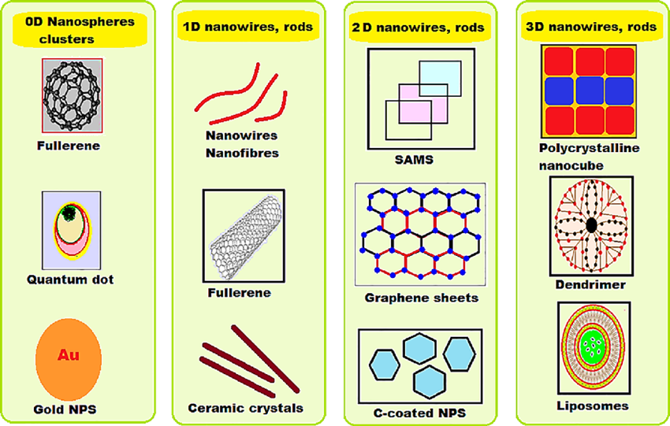

# **Figure:** Classification of nanomaterial on the basis of dimension**6**

**(b) Classification based on their origin:**

1. **Natural nanomaterials:** Nanomaterials which are belonging to resource of nature are defined as natural nanomaterials. Virus, protein molecules including antibody originated from nature are some examples of natural nano structured materials.

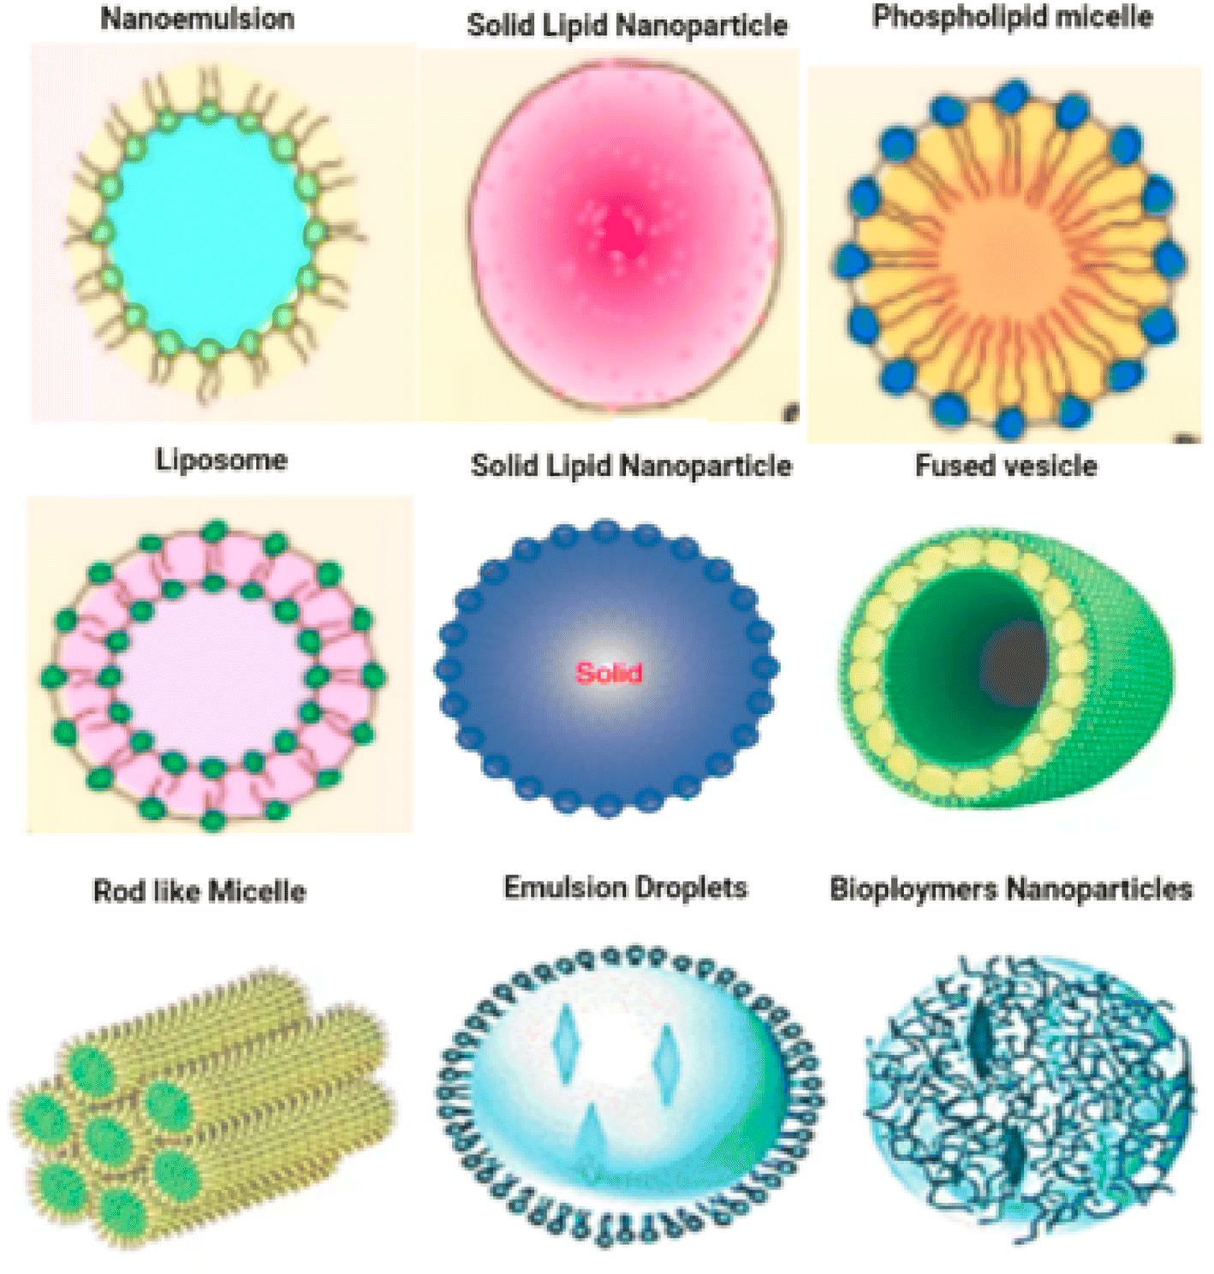

**Figure:** Some examples of Bionanoparticles

**ii) Artificial nanomaterials:** Artificial nanoparticles are those which are prepared deliberately through a well-defined mechanical and fabrication process. The examples of such materials are carbon nanotubes, semiconductor nanoparticles like quantum dots etc.

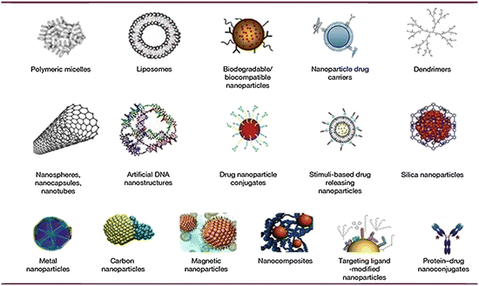

**Figure:** Some examples of Artificial nanomaterials

**(c) Classification based on structural configuration:**

1. **Carbon based nano-materials:** The nature of this kind of nanomaterials is hollow spheres, ellipsoids, or tubes. Spherical and ellipsoidal configured carbon nanomaterials are defined as fullerenes, while cylindrical ones are described as nanotubes.

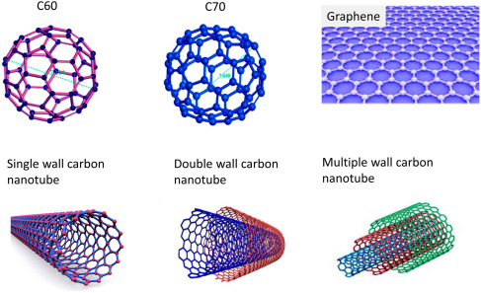

***Figure:*** *Different types of carbon based nanomaterials including fullerenes (C60 and C70), graphene and its derivatives, and carbon nanotubes (CNTs)****7***

1. **Metal Based Materials:** The main component of these particles is metal. These nanomaterials include nanogold, nanosilver and metal oxides, such as titanium dioxide and closely packed semiconductor like quantum dots.

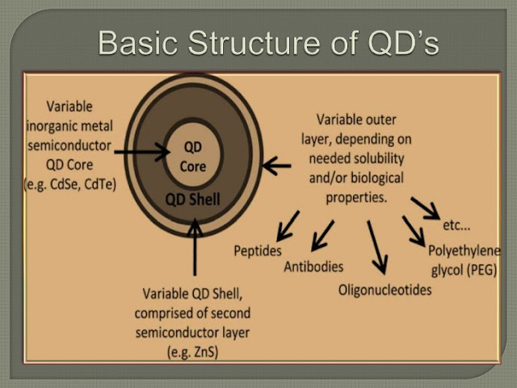

***Figure:*** *Basic structure of Quantum Dot****8***

**iii) Dendrimers:** Dendrimers are highly branched macromolecules with the dimensions nanometer-scale. The surface of a dendrimer posses numerous chain which can be modified to perform specific chemical functions. PAMAM (poly(amidoamine))  dendrimer is the best illustration of this kind of materials.**9**

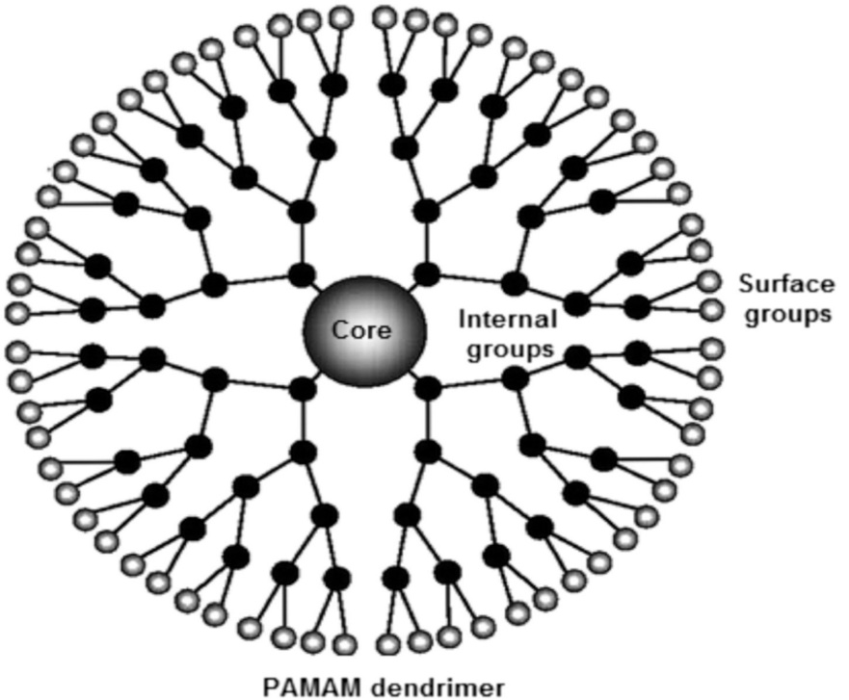

**Figure:** Structure of PAMAM dendrimer

1. **Composites**: Nanocomposite can be described as a multiphase solid material where at least one of the phases has one, two or three dimensions in nanoscale. The most common examples of these materials are colloids, gels and copolymers. In mechanical terms, nanocomposites differ from conventional [composite materials](https://en.wikipedia.org/wiki/Composite_material) due to the exceptionally high surface to volume ratio of the reinforcing phase and/or its exceptionally high [aspect ratio](https://en.wikipedia.org/wiki/Aspect_ratio). The reinforcing material can be made up of particles (e.g. minerals), sheets (e.g. exfoliated clay stacks) or fibres (e.g. carbon nanotubes or electrospun fibres).

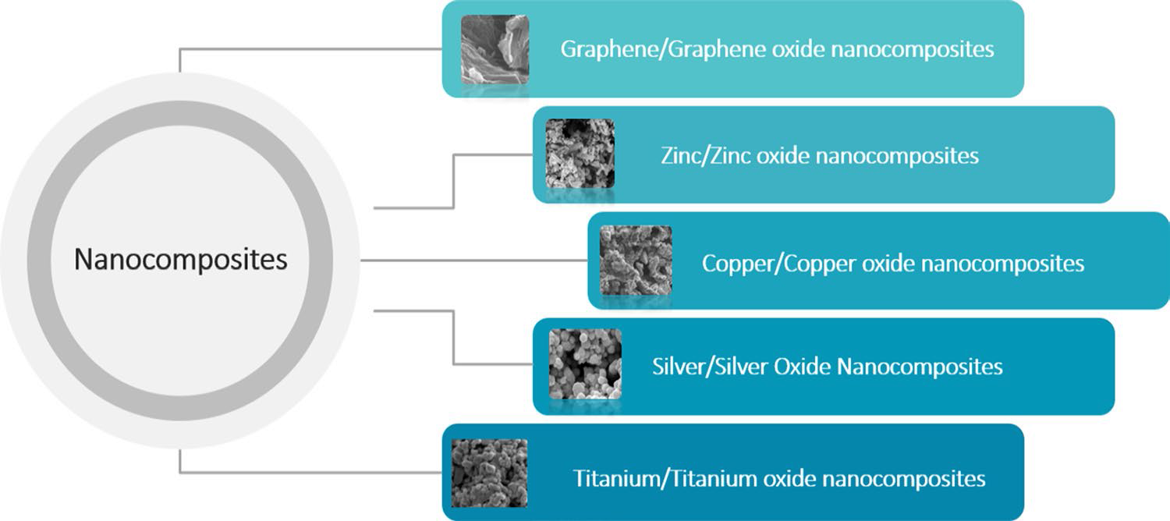

***Figure:*** *Some examples of Nanocomposites****10***

**Applications of nanomaterials:**

Nanotechnology offers an extremely wide range of potential applications from electronics, optical communications and biological systems to new materials. Nanomaterials can be useful for following aspects-

1. **Nanowires for junctionless transistors:** Junctionless nanowire transistors (JNTs) are a type of field-effect transistor (FET) where the channel consists of one or more nanowires and does not contain a junction, offering advantages like low leakage currents and excellent short channel behavior. They are essentially gated resistors, where the flow of current through the nanowire is controlled by a gate electrode.  The process of fabricating JNTs is relatively simple, as there is no need for creating junctions or doping gradients.**11**

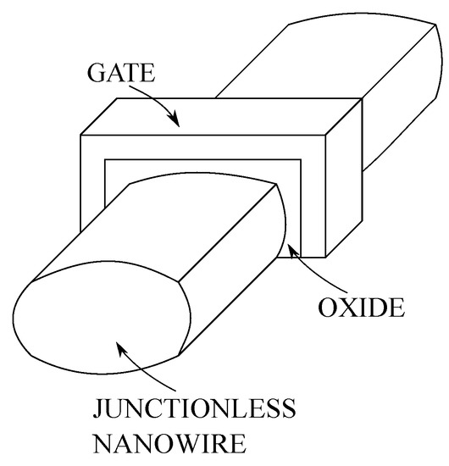

**Figure:** Schematic Diagram of Junctionless Transistors

(ii) **Next-Generation Computer Chips:** Nanomaterials are paving the way for next-generation computer chips with the potential for increased processing speeds, energy efficiency, and enhanced storage capacities, as they enable the creation of smaller, more powerful, and versatile devices. Nanoscale transistors, made possible by materials like carbon nanotubes and graphene, can significantly boost processing speeds and reduce power consumption.

1. **Elimination of Pollutants:** Nanomaterials offer promising solutions for eliminating pollutants, leveraging their unique properties for adsorption, photocatalysis, and membrane filtration to remove contaminants from water, air, and soil. For example**12**:

* Carbon nanotubes, graphene, and activated carbon are effective adsorbents for removing organic and inorganic pollutants, including heavy metals.
* Metal oxides (like TiO2) and metal sulfides (like In2S3) are used in photocatalysis to degrade pollutants, and metal nanoparticles can be used for adsorption.
* Nanomaterials with high surface area can trap pollutants on their surfaces, effectively removing them from the environment.
* Nanostructured membranes can selectively allow certain substances to pass through while retaining pollutants, effectively separating them from the target medium.

1. **Sun-screen lotion :** Nanomaterials, characterized by their minute size on the nanometer scale, have revolutionized the efficacy, aesthetics, and functionality of sun-care products. Among these, titanium dioxide and zinc oxide nanoparticles have gained considerable attention for their unparalleled ability to shield against harmful ultraviolet (UV) rays.  Sunscreen lotions contain nanoparticles of zinc oxide (ZnO) and titanium dioxide (TiO2). These chemicals protect the skin against harmful UV (ultraviolet) rays by absorbing or reflecting the light.

**(V) Sensors:** Nanosensors are nanoscale devices that detect and measure physical or chemical changes, converting them into detectable signals, with applications ranging from medical diagnosis to environmental monitoring. They convert physical or chemical changes (like temperature, pressure, or chemical concentration) into measurable signals. For example: Carbon nanotubes are used to detect changes in vibrational frequency when particles attach, Graphene-based sensors for monitoring structural health in bridges, Metal-organic framework (MOF) nanosensors for gas sensing.**13**

Nanosensors can be classified as follow-

* **Chemical Nanosensors:** Detect and measure chemical species or nanoparticles.
* **Mechanical Nanosensors:** Detect and measure physical parameters like temperature or pressure.
* **Biological Nanosensors:** Detect and measure biological molecules or processes.
* **Magnetic Nanosensors:** Use magnetic nanoparticles to detect specific molecules.
  1. **Phosphors for High-Definition TV :** For high-definition television (HDTV) screens, phosphors, which are materials that emit light when struck by electrons, are essential, and nanomaterials like zinc selenide, cadmium sulfide, zinc sulfide, and lead telluride, synthesized via sol-gel methods, are used to enhance resolution. **Examples of Phosphors:**
  + **P22R:** Y2O2S:Eu+Fe2O3 (Red phosphor)
  + **P22G:** (Zn,Cd)S:Cu,Al (Green phosphor)
  + **P22B:** ZnS:Ag+Co-on-Al2O3 (Blue phosphor)
  1. **Catalysis:** Nanomaterials can be used as nanocatalysts. A **nanocatalyst** is a catalyst that operates at the nanoscale, typically composed of nanoparticles or nanostructured materials. These catalysts have high surface area-to-volume ratios, which significantly enhance their reactivity, selectivity, and efficiency compared to bulk catalysts. Some examples of nanocatalysts are gold (Au), TiO₂, Fe₂O₃, graphene, carbon nanotubes (CNTs) and Single-Atom Catalysts (SACs) etc. Nanocatalysts have applications in following fields:

• **Energy production** – Hydrogen generation, fuel cells.

• **Environmental remediation** – Water purification, air pollution control.

• **Chemical synthesis** – Petrochemical processing, pharmaceuticals.

• **Electrocatalysis** – Batteries, supercapacitors.

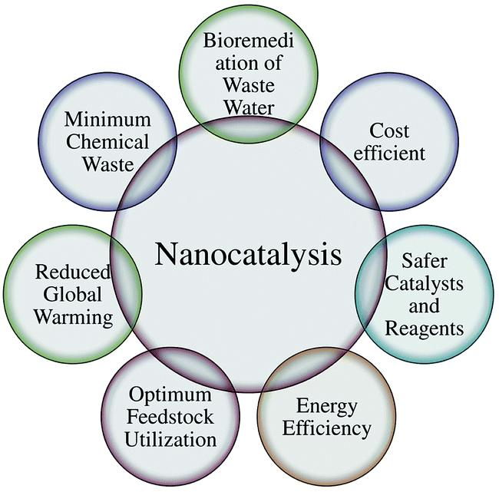

***Figure:*** *Advantages of Nanocatalysts****14***

* 1. **Fuel cells:** Nanomaterials are revolutionizing fuel cell technology, enhancing efficiency, durability, and reducing costs by increasing surface area, improving catalytic activity, and enabling new materials for membranes and electrodes. Nanomaterials, like platinum nanoparticles, offer a significantly larger surface area compared to their bulk counterparts, leading to more active sites for electrochemical reactions and improved catalyst efficiency.They can potentially reduce the amount of expensive catalysts needed, like platinum, making fuel cell technology more affordable.

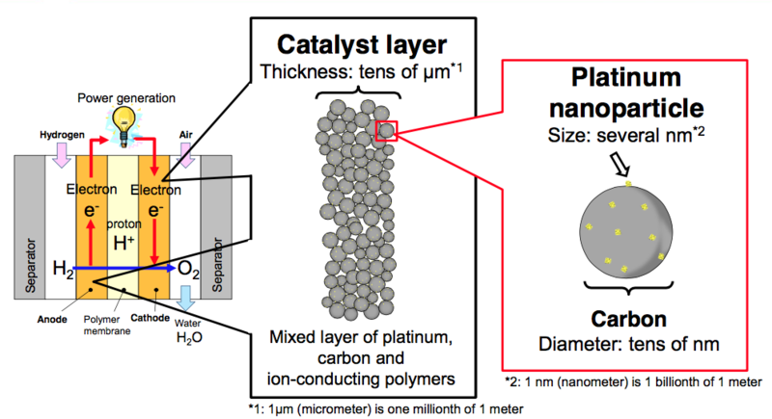

***Figure:*** *Schematic of a fuel cell where anodes and cathodes are primarily composed of platinum nanoparticles and carbon. Platinum nanoparticles are complex bodies of platinum atoms (hundreds of thousands to millions of atoms).****15***

**Synthesis of Nanomaterials:**

There are two general approaches to the synthesis of nanomaterials and the fabrication of nanostructures. They are :

(1) top-down method of miniaturizing materials, and

(2) bottom-up method of building molecular structures atom by atom or molecule by molecule.**16**

**Top-down approach-**

The top-down approach has been advanced by Richard Feynman in 1959 lecture stating that “there is plenty of room at the bottom” and it is ideal for obtaining structures with long-range order and for making connections with macroscopic world. This approach uses larger (macroscopic) initial structures, which can be externally controlled in the processing of nanostructures.

Typical examples are photolithography, etching through the mask, ball milling and application of severe plastic deformation.

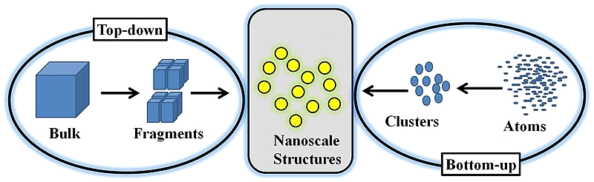

***Figure :*** *Illustration of the top-down and bottom-up approach for making nanoparticles. Image by Vicente Neto/CC By 4.0*

**Bottom-up approach-**

The bottom-up approach was pioneered by Jean-Marie Lehn (revealing that “there is plenty of room at the top”) and it is best suited for assembly and establishing short-range order at the nanoscale. This approach includes the miniaturization of materials components (up to atomic level) with further self assembly process leading to the formation of nanostructures. During self-assembly the physical forces operating at nanoscale are used to combine basic units into larger stable structures.

Examples- 1. sol-gel processing, 2. chemical vapour deposition (CVD), 3. plasma or flame spraying synthesis, 4. laser pyrolysis, 5. atomic or molecular condensation – Inert gas condensation.

Here we will talk about some important physical and chemical methods of synthesis of nanomaterials as follow:

1. **Physical Vapor Deposition:** The PVD method recrystallizes the material through the gas–solid phase reaction to obtain 2D thin-film materials. It creates thin films by removing atoms from a solid or liquid source and depositing them onto a substrate.**17**

PVD processes occur in a vacuum chamber to allow the vaporized material to travel unimpeded to the substrate. The material to be deposited is heated (through methods like thermal evaporation, electron beam evaporation, or sputtering) to a high temperature, causing it to vaporize. The vaporized material then condenses and solidifies on the substrate, forming a thin film. Some examples of common PVD techniques are:

* **Thermal Evaporation**
* **Electron Beam Evaporation**
* **Sputtering**
* **Arc Evaporation**
* **Pulsed Laser Deposition (PLD)**
* **Ion Plating**

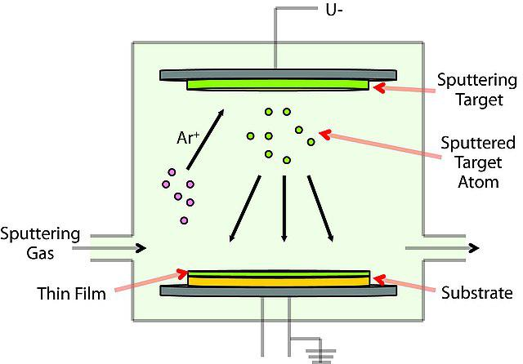

***Figure:*** *Instrumentation of PVD process*

1. **Solvothermal Synthesis:**

In this process the precursor materials are dissolved in a solvent and the reaction is performed in a sealed container under controlled temperature and pressure.

Solvothermal synthesis involves conducting chemical reactions in a closed vessel (like an autoclave) where a solvent, containing reagents, is heated to a temperature exceeding its boiling point, creating a high-pressure environment. The high temperature and pressure facilitate chemical reactions between precursors (starting materials) in the solvent, leading to the formation of desired materials, often nanoparticles or nanomaterials.**18**

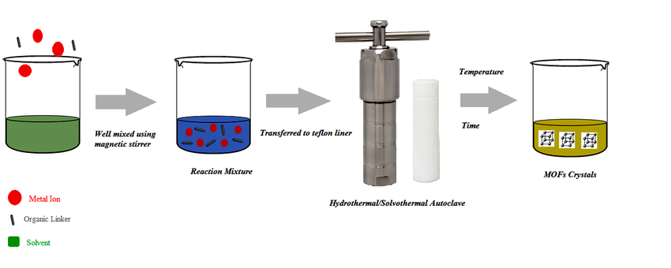***Figure****: A Schematic diagram of Solvothermal Synthesis*

1. **Mechanical** **Exfoliation (Scotch Tape Method):** Mechanical exfoliation is a top-down approach to produce 2D nanomaterials by applying mechanical forces to break the van der Waals interactions between layers of a bulk material, resulting in thin flakes or sheets.

In this method, a piece of adhesive tape is used to peel off thin layers from a bulk crystal of the target material. The thin flakes are then transferred onto a substrate, such as silicon or sapphire. This method has been used to isolate thin flakes of materials like Cr2Ge2Te6, FePS3 and others.**19**

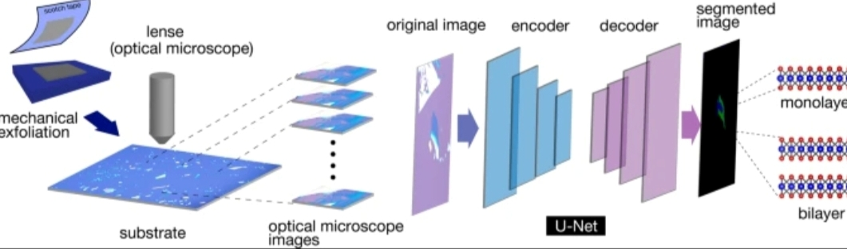

***Figure:*** *Process of Mechanical Exfoliation on a 2D crystal*

**(iv) Gas phase condensation:**

Gas-phase condensation processes are one of the oldest methods for materials processing and have many advantages over other nanoparticle synthesis techniques. Gas-phase condensation is a bottom-up protocol for producing nanosized material. They provide the capability to precisely control the process parameters,to produce nanostructures with preferred morphology along with desired chemical composition. These synthesis techniques are based on homogenous nucleation in the gas phase and subsequent condensation and coagulation.**20** The basic working mechanism for all these techniques is the same and can be summarized as follows:

* Suspending the target material in gas phase
* Conversion of the target material into small clusters
* Enforcing the growth of these clusters to nanoparticles
* Collection of synthesized nanomaterials



***Figure:*** *Schematics of Gas phase condensation equipment*

1. **Chemical Vapor Deposition (CVD) Technique for Nanomaterials:**

Chemical Vapor Deposition (CVD) is a widely used technique for synthesizing high-quality nanomaterials, such as carbon nanotubes (CNTs), graphene, and various metal and metal oxide nanoparticles. The process involves the decomposition of volatile precursors in the gas phase, leading to the formation of a solid material on a substrate.

In a typical CVS process metal organic precursor is inserted into the hot wall reactor at controlled rate. For producing halide, nitride, carbide, or metal oxide nanoparticles, the reaction chamber is filled with respective reactive gas precursors. If a mixture of gas reactants is introduced in the reactor, the energy (produced from resistant heating, laser, or plasma heating) can cause chemical reactions among them. For producing oxides, chlorides are the most popular precursors owing to their characteristically low vaporization temperatures and low cost. A common chemical reaction taing place inside the reactor involving chlorides is as follows:**21**

SnCl4 (g) + 2H2O (g) → SnO2 (s) + 4HCl (g)



***Figure:*** *Schematic representation of the experimental setup employed for CVS method.*

**(v)** **Sol-gel method**: It is a widely used bottom-up approach for synthesizing nanomaterials, particularly metal oxides. It involves the transition of a solution (sol) into a solid gel-like network (gel), followed by drying and heat treatment to obtain the desired nanomaterial.   
The sol-gel process consists of hydrolysis and condensation reactions that convert molecular precursors into a gel, which is then processed into nanoparticles, thin films, or porous materials. The key steps involved in sol-gel process are as follow:**22**

1. **Preparation of Precursor Solution (Sol Formation)**
   * A metal precursor (metal alkoxide or metal salt) is dissolved in a solvent (e.g., ethanol, water).
   * Example: *Tetraethyl orthosilicate (TEOS) for silica (SiO₂) nanoparticles.*
2. **Hydrolysis Reaction**
   * The metal precursor reacts with water to form hydroxyl (-OH) groups.
   * Example: M(OR)n+H2O→M(OH)n+ROHM(OR)_n + H_2O → M(OH)_n + ROHM(OR)n​+H2​O→M(OH)n​+ROH
   * (*M = Metal, OR = Alkoxide group*)
3. **Condensation Reaction (Gel Formation)**
   * Hydroxyl groups undergo condensation, forming metal-oxygen-metal (M-O-M) bonds, creating a 3D gel network.
   * Example: M(OH)n+M(OH)n→M−O−M+H2OM(OH)_n + M(OH)_n → M-O-M + H_2OM(OH)n​+M(OH)n​→M−O−M+H2​O
4. **Aging and Drying**
   * The gel is aged to strengthen the network.
   * Drying removes solvents, leading to a xerogel (dried gel).
5. **Calcination (Heat Treatment)**
   * The gel is heated at high temperatures (300–800°C) to remove organic residues and crystallize the material.

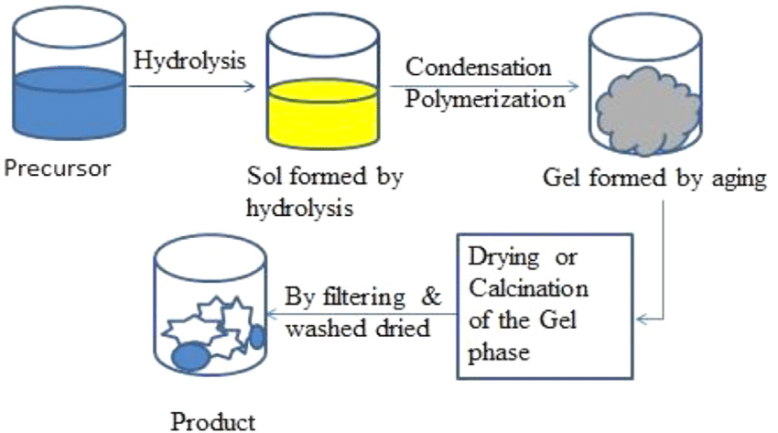

***Figure****: Schematic diagram of sol-gel process*

1. **Precipitation method** : This **method** is a simple and widely used bottom-up technique for synthesizing nanomaterials. It involves the formation of solid nanoparticles from a supersaturated solution by controlled chemical reactions. In this process a precursor solution (metal salt) reacts with a precipitating agent (e.g., base, reducing agent) to form insoluble nanoparticles. The **key steps** involved in precipitation methos are:**23**

* Preparation of a Supersaturated solution
* Addition of a Precipitating agent
* Nucleation & Growth
* Separation & Washing and
* Drying & Calcination

## **Some examples of precipitation reactions are-**

1. **Zinc Oxide (ZnO) Nanoparticles:**

Zn(NO3​)2​+2NaOH→Zn(OH)2​↓→ZnO+H2​O

1. **Calcium Carbonate (CaCO₃) Nanoparticles:**

CaCl2​+Na2​CO3​→CaCO3​↓+2NaCl

1. **Iron Oxide (Fe₃O₄) Nanoparticles:**

FeCl2​+FeCl3​+NH4​OH→Fe3​O4​↓+NH4​Cl+H2​O

1. **Ball Milling:** Ball milling is one of the most common and the most cost-effective mechanochemical technique to prepare nanosized metal particles using hard balls of stainless steel, [tungsten](https://www.sciencedirect.com/topics/materials-science/tungsten), ceramic, etc. Ball milling is the mechanical grinding of solid materials using hard balls of stainless steel, [tungsten carbide](https://www.sciencedirect.com/topics/chemical-engineering/tungsten-carbide), etc. The main advantage of high-energy mechanical ball milling is that in one step, it can produce a large quantity of [metal hydrides](https://www.sciencedirect.com/topics/materials-science/metal-hydride) with desired properties. Ball milling is generally done under an [inert gas](https://www.sciencedirect.com/topics/materials-science/inert-gas) environment because metal hydrides are sensitive to air and water. The structure of nanosized metal hydrides prepared from the mechanochemical process have different [grain structures](https://www.sciencedirect.com/topics/materials-science/crystal-microstructure), dislocations, and surface and internal fractures.**24**

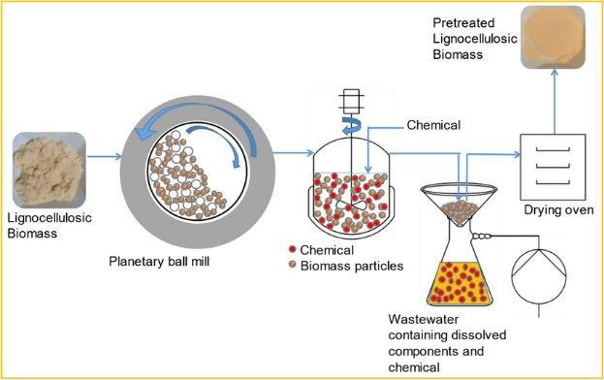

***Figure:*** *Schematic of Ball Milling Process*

**Characterization of Nanomaterials:**

Characterization of nanomaterials involves analyzing their physical, chemical, structural, and functional properties. Various techniques are used depending on the specific characteristics being studied. Here are the key aspects of nanomaterial characterization:

* 1. **X-ray Diffraction:**

X-ray diffraction (XRD) is a powerful method for the study of nanomaterials (materials with structural features of at least one dimension in the range of 1-100 nm). The wavelength of X-rays is on the atomic scale, so X-ray diffraction (XRD) is a primary tool for probing structure of nano-materials. XRD offers unparalleled accuracy in the measurement of atomic spacing and is the technique of choice for determining strain states in thin films. The intensities measured with XRD can provide quantitative, accurate information on the atomic arrangements at interfaces. With lab-based equipment, surface sensitivities down to a thickness of ~50A0 are achievable, but synchrotron radiation allows the characterization of much thinner films and for many materials, monoatomic layers can be analyzed. XRD is non contact and non-destructive, which makes it ideal for in situ studies. Nanomaterials have a characteristic microstructure length comparable with the critical length scales of physical phenomena, giving them unique mechanical, optical and electronic properties. X-ray diffractograms of nanomaterials provide a wealth of nformation - from phase composition to crystallite size, from lattice strain to crystallographic orientation. The main use of powder diffraction is to identify components in a sample by a search/match procedure. Furthermore, the areas under the peak are related to the amount of each phase present in the sample.**25**

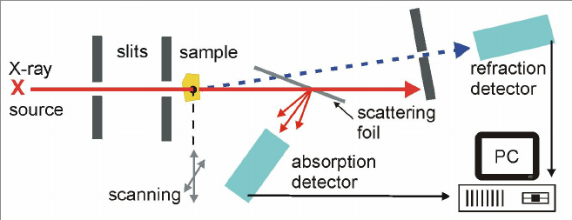

***Figure:******Instrumentation of X-ray Diffraction***

* 1. **UV Visibe Spectroscopy:**

Ultraviolet (UV) spectroscopy is an important physical tool which exploits light in ultraviolet, visible, and near infrared range of electromagnetic spectrum. Beer-Lambert law establishes a linear relationship between absorbance, concentration of absorbers (or absorbing species) in the solution and the path length. Therefore, UV-Vis spectroscopy can be employed for determining the concentration of the absorbing species, for a fixed path length.

**In UV-Visible Spectroscopy** a light beam is passed through an object and wavelength of the light reaching the detector is measured. The measured wavelength provides important information about chemical structure and number of molecules (present in intensity of the measured signal). Thus, both quantitative and qualitative information can be gathered. Information may be obtained as transmittance, absorbance or reflectance of radiation in 160 to 3500 nm wavelength range. The absorption of incident energy promotes electrons to excited states or the anti-bonding orbitals. For this transfer to occur, photon energy must match the energy needed by electron to be promoted to next higher energy state. This process forms the basic operating principle of absorption spectroscopy.**26**

A uv visible spectrometer consists of:

* **UV Source**
* **Visible Light Source**
* **Cuvettes &**
* **Detectors**

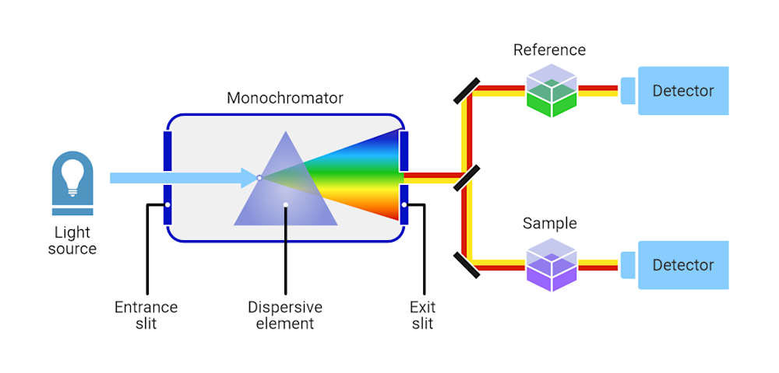

***Figure:*** *UV-Visible Spectroscopy*

* 1. **SEM :**

SEM stands for Scanning Electron Microscopy, a technique that uses a focused beam of electrons to image the surface topography and composition of a sample, providing high-resolution images. In SEM The electrons interact with the atoms in the sample, producing various signals (like secondary and backscattered electrons) that contain information about the surface topography and composition. SEM offers high magnification and resolution compared to optical microscopy, allowing for detailed visualization of surfaces at the nanoscale.**27**

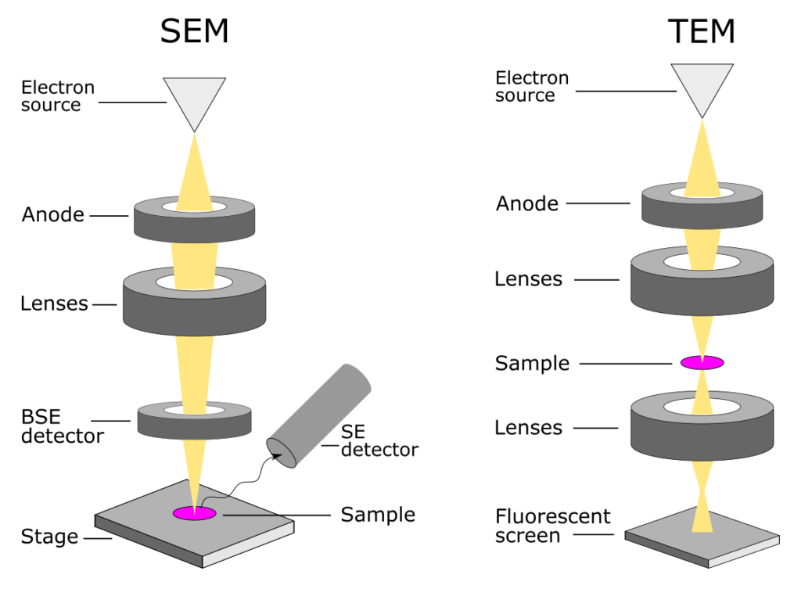

***Figure:*** *Instrumentation of SEM & TEM Microscopes*

* 1. **TEM:**

Transmission Electron Microscopy (TEM) is a high-resolution imaging technique used to analyze the structural, morphological, and compositional properties of materials at the atomic scale. In this, a high-energy electron beam (100–300 keV) is transmitted through a thin sample. As electrons interact with the sample, they are scattered based on the atomic structure, producing detailed images and diffraction patterns. Signals from transmitted or scattered electrons provide information about the sample’s structure, composition, and defects.**27**

* 1. **AFM:**

**AFM (Atomic Force Microscopy)** is a powerful technique that can image almost any type of surface, including polymers, ceramics, composites, glass and biological samples. AFM is used to measure and localize many forces, including adhesion strength, magnetic forces and mechanical properties. AFM is performed using a sharp tip about 10-200 nm in diameter attached to a cantilever. AFM tips and cantilevers are microfabricated from Si or Si3N4. The tip moves in response to tip-surface interactions, and this movement is measured by focusing a laser beam on the tip with a photodiode.**28**

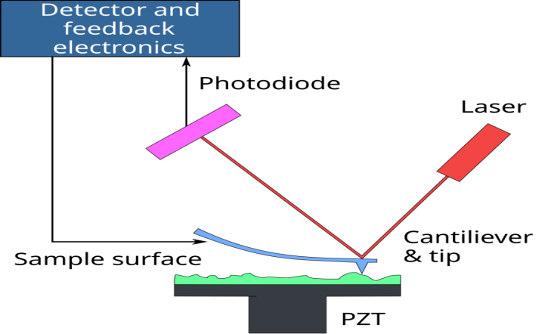

***Figure:*** *Instrumentation of Atomic Force Microscope*

* 1. **Magnetic Properties:**

Characterizing the magnetic properties of nanomaterials involves assessing their magnetic behavior, including magnetization, coercivity, and superparamagnetism, using techniques like vibrating sample magnetometry (VSM) and magneto-optical Kerr effect (MOKE). We can understand these characterization techniques as follow:

* **Vibrating Sample Magnetometry (VSM)**

The VSM is the instrument used to measure the magnetic moment, hysteresis loops and coercivity, the most fundamental quantity in magnetism, of solid samples. The instrument displays the magnetic moment in e.m.u. units. It operates by measuring the EMF induced in pickup coils due to a sample’s magnetic moment.**29**

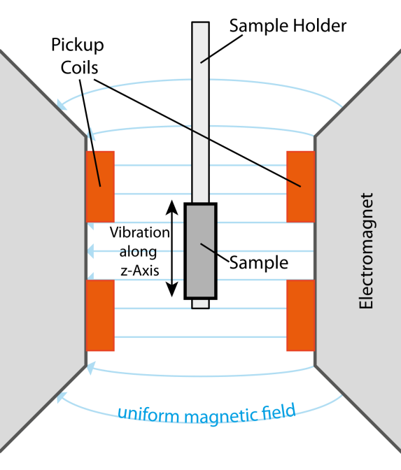

***Figure:*** *Schematic diagram of a VSM*

* **Magneto-Optical Kerr Effect (MOKE):**

The Magneto-Optical Kerr Effect (MOKE) in nanomaterials studies the interaction of light with magnetic materials, specifically the change in reflected light polarization due to magnetization, providing a powerful tool for characterizing magnetic properties and magnetization behavior in nanostructures. MOKE allows for non-destructive characterization of magnetic properties in nanomaterials, including measuring magnetic hysteresis loops, imaging magnetic domains, and studying magnetization dynamics.**30**

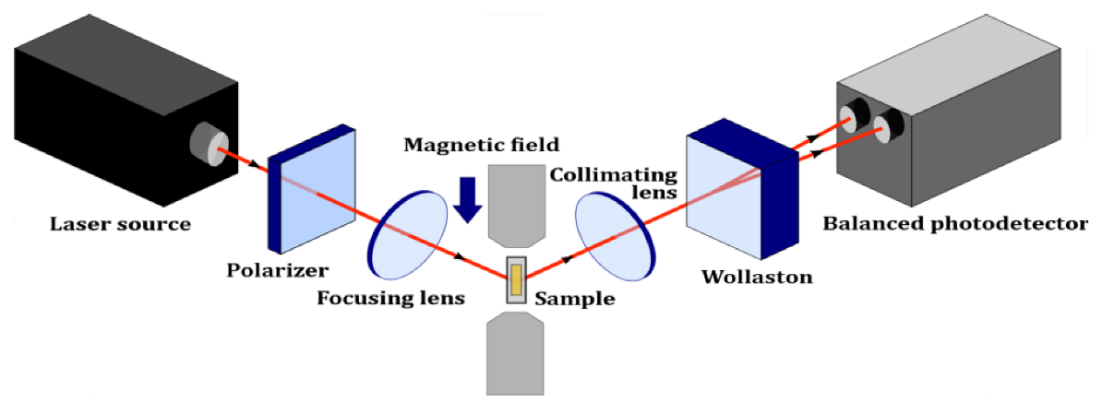

***Figure:****Schematic diagram of the transverse magneto-optical Kerr effect (TMOKE) setup.*

* 1. **Ultrasonic Spectroscopy:**

Ultrasonic spectroscopy is a non-destructive technique that uses high-frequency acoustic waves to analyze materials, probing their microstructure, intermolecular interactions, and constitution. It measures ultrasonic velocity and attenuation as a function of frequency, allowing for the determination of properties like particle size distribution in colloids and emulsions. It measures how these waves propagate through the material, including their velocity and attenuation (loss of energy). By analyzing these measurements across a range of frequencies, researchers can gain insights into the material's properties.**30**

Ultrasonic Spectroscopy has following advantages:

* **Non-destructive:** The technique does not damage the sample being analyzed.
* **In-situ Analysis:** Measurements can be performed on the sample in its natural environment.
* **Rapid Analysis:** Ultrasonic spectroscopy is a relatively fast method for obtaining material properties.

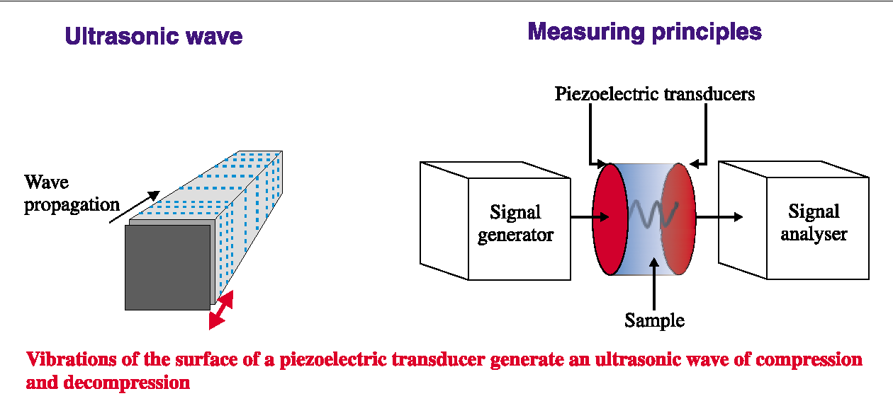

***Figure:*** *The general instrumentation of high-resolution ultrasonic spectroscopy****30***

**Nanoscience for Sustainable Technologies**

Nanoscience and nanotechnology offer promising solutions for sustainable technologies, addressing global challenges in areas like energy, water, food, and healthcare through materials with unique properties and enhanced capabilities.

Nanoscience is proving to be a powerful tool in the pursuit of sustainable technologies. Its ability to manipulate materials at the nanoscale allows for the creation of solutions that are more efficient, less wasteful, and environmentally friendly.

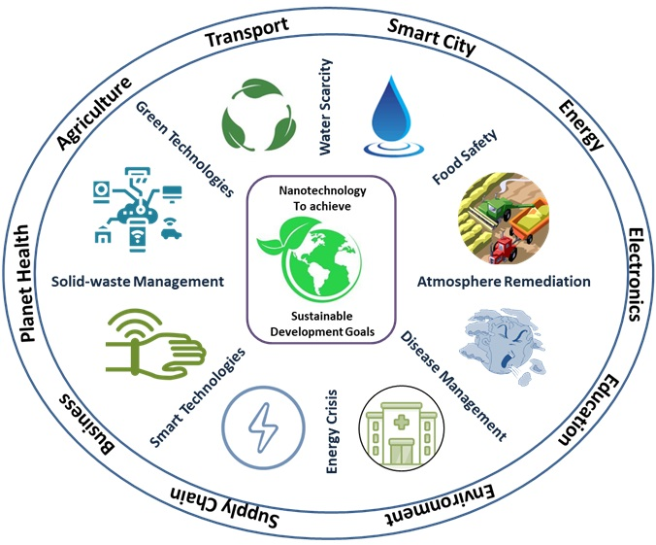

***Figure:*** *Nanotechnology to attain sustainable development goals by addressing global challenges****31***

Here's a more detailed look at how nanoscience contributes to sustainable technologies:

* + 1. **Energy:** Nanoscience and nanotechnology offer significant potential for revolutionizing energy generation, storage, and utilization by enabling the development of more efficient and sustainable technologies, such as improved solar cells, batteries, and fuel cells.

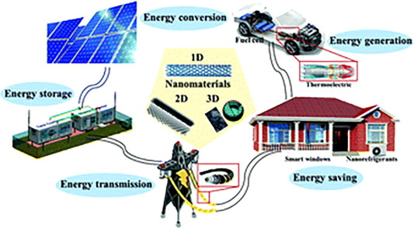

***Figure:*** *Applications of nanomaterials in Energy Sector*

 Here's a more detailed look at the applications of nanoscience in the energy sector:

* **Renewable Energy:**

1. **Solar Energy:**
   1. Nanomaterials like quantum dots and carbon nanotubes enhance light absorption and charge separation in solar cells, leading to increased efficiency.
   2. Nanostructured silicon or titanium dioxide can increase the surface area of solar cells, allowing for more efficient light absorption.
   3. Nanofluids can improve the heat transfer efficiency of solar collectors.

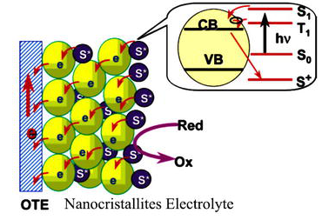

***Figure:*** *Schematic of a nanocrystalline Electrolyte used in Solar Cell****32***

1. **Wind Energy:**

Lightweight and durable nanocomposite materials for turbine blades can improve wind energy efficiency.

1. **Fuel Cells:**
   1. Nanostructured catalysts can increase the efficiency of fuel cells.
   2. Nanomaterials like carbon nanotubes and nanostructured metal oxides can substantially improve the performance of fuel cell electrodes.
2. **Hydrogen Storage:**

Nanomaterials offer promising solutions for hydrogen storage due to their high surface area and unique properties, enabling efficient physical or chemical adsorption of hydrogen molecules, with materials like carbon nanotubes, metal hydrides, and metal-organic frameworks (MOFs) being key players.  Porous nanomaterials can be used for efficient hydrogen storage.

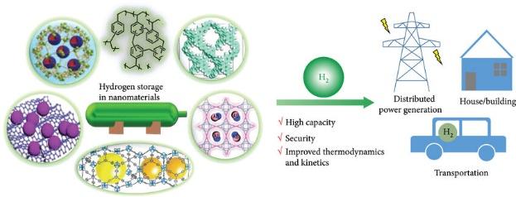***Figure:*** *Schematic illustration showing the hydrogen storage in nanomaterials and its sustainable applications****33***

1. **Biomass Energy:**

Nano-based precision farming can optimize crop use for biofuel production. Biomass-derived nanomaterials offer promising avenues for sustainable energy solutions, with applications ranging from energy storage in supercapacitors and batteries to energy conversion in fuel cells and biofuels, leveraging the unique properties of nanomaterials derived from biomass sources like plants and algae.

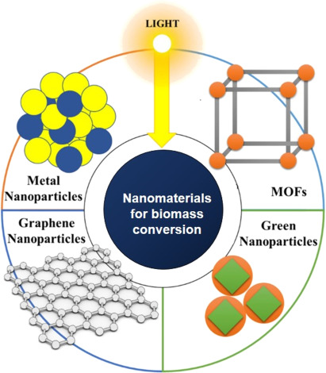

***Figure:*** *Nanomaterials for biomass conversion****34***

* **Energy Storage:**
  + - 1. **Batteries:** Nanobatteries are energy storage devices that use nanotechnology to improve performance, efficiency, and sustainability. By incorporating nanoscale materials into electrodes, electrolytes, and separators, these batteries achieve **higher energy densities, faster charging times, and longer lifespans** compared to traditional batteries.Nanostructured electrodes made of materials like silicon, iron oxide, and titanium oxide increase charge storage capacity and battery life.Nanomaterials enhance electrode materials, electrolytes, and nanostructured architectures in batteries, supercapacitors, and other energy storage devices.

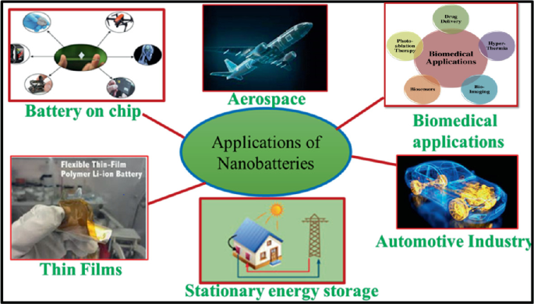

***Figure:*** *Applications of Nanobatteries*

* + - 1. **Supercapacitors:**

Nanosupercapacitors are advanced energy storage devices that use **nanotechnology** to achieve **ultra-fast charging, high power density, and long lifespans**. Unlike traditional batteries, they store energy **electrostatically** instead of chemically, allowing for rapid charge and discharge cycles. Nanomaterials improve the performance and longevity of supercapacitors. Key nanomaterials used in nano supercapacitors are as follow:**35**

1. **Graphene-Based Nanosupercapacitors**
2. **Carbon Nanotube (CNT) Supercapacitors**
3. **Metal Oxide Nanostructures**
4. **MXene-Based Supercapacitors**

**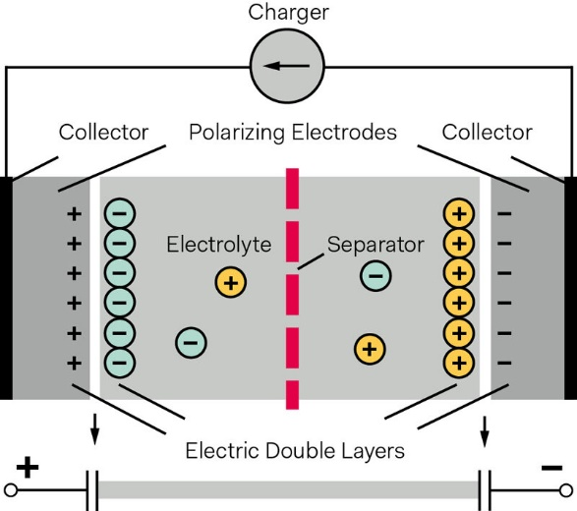*Figure:*** *Nano Supercapacitors With Very High Capacity*

* **Energy Efficiency and Conservation:**

1. **Fuel Additives:** Nanoparticles enhance heat transfer in the combustion chamber, leading to a more uniform temperature distribution and efficient fuel utilization. Nanomaterials can prevent fuel degradation by acting as antioxidants and reducing oxidative stress. Adding nanoparticles improves fuel atomization and energy release, leading to better power output and fuel economy. Metal nanoparticles like Fe, Cu, and Al increase the calorific value of the fuel. Nanoparticles, such as cerium oxide (CeO₂) and aluminum oxide (Al₂O₃), act as catalysts that promote more complete fuel combustion, reducing unburned hydrocarbons.

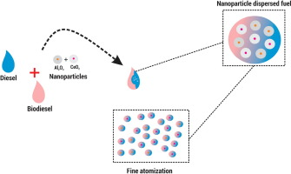

***Figure:*** *Nanomaterials as fuel additives*

1. **Thermal Insulation:** Nanomaterials are revolutionizing thermal insulation by offering superior heat resistance, low thermal conductivity, and lightweight properties. Their nanoscale structures minimize heat transfer via conduction, convection, and radiation, making them ideal for various applications, from aerospace to construction. Nanoporous structures, such as aerogels, trap air and reduce heat conduction. They increases interaction with heat, effectively dissipating it before transfer. Examples of nanomaterials used in thermal insulation are:

* **Aerogels**
* **Metal Oxide Nanoparticles (TiO₂, Al₂O₃, SiO₂**
* **Polymer-based nanocomposite**
  + 1. **Water Purification** and Treatment**:** Nanomaterials are transforming water purification by offering efficient solutions for contaminant removal, desalination, and water disinfection. Their high surface area, reactivity, and unique physicochemical properties make them highly effective in addressing water pollution.

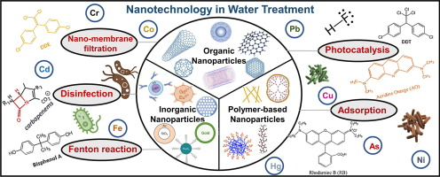

***Figure:*** *Nanomaterials in Water Treatment*

## **Key Applications of Nanomaterials in Water Treatment can be described as follow:36**

### ****Heavy Metal Removal****

* **Carbon Nanotubes (CNTs):** Adsorb heavy metals like lead (Pb), mercury (Hg), and arsenic (As).
* **Graphene Oxide (GO):** Efficiently binds to metal ions due to its high surface area and functional groups.
* **Iron Oxide Nanoparticles (Fe₃O₄):** Used for magnetic separation of heavy metals.

### ****Organic Pollutant and Dye Degradation****

* **Titanium Dioxide (TiO₂) Nanoparticles:** Act as photocatalysts to break down organic pollutants under UV light.
* **Zinc Oxide (ZnO) Nanoparticles:** Degrade dyes and pharmaceutical residues in wastewater.
* **Silver (Ag) Nanoparticles:** Enhance oxidation processes for organic pollutant removal.

### ****Water Desalination****

* **Carbon-Based Nanomaterials (Graphene & CNTs):** Used in next-generation membranes for salt and impurity removal.
* **Nanoporous Materials:** Improve water permeability while rejecting salts in reverse osmosis (RO) membranes.

### ****Bacterial & Viral Disinfection****

* **Silver Nanoparticles (AgNPs):** Have strong antibacterial properties, disrupting bacterial cell membranes.
* **Copper Oxide (CuO) & Zinc Oxide (ZnO):** Effective against pathogens by generating reactive oxygen species (ROS).
* **Chitosan-Based Nanomaterials:** Naturally antimicrobial and used in filtration systems.

### ****Smart Nanofilters and Membranes****

* **Nano-Enhanced Membranes:** Provide selective filtration with increased efficiency and durability.
* **Electrospun Nanofiber Filters:** Trap bacteria, viruses, and microplastics from water.
  + 1. **Food:** Nanomaterials offer several advantages in the food industry, including enhanced food safety, improved shelf life, and potential for creating functional foods with better nutritional value and sensory properties.  For example nanomaterials, like silver and titanium dioxide nanoparticles, can inhibit the growth of microorganisms, reducing the risk of food spoilage and contamination.

Nanomaterials can be used to develop smart packaging that can monitor the quality of food during storage and transportation, providing real-time information about its freshness and safety.  Nanomaterials can be incorporated into food packaging to create stronger, more flexible, and gas-impermeable barriers, extending shelf life and preserving food quality.

Nanosensors can detect food spoilage, toxins, and pathogens at early stages, allowing for timely intervention and preventing foodborne illnesses.

**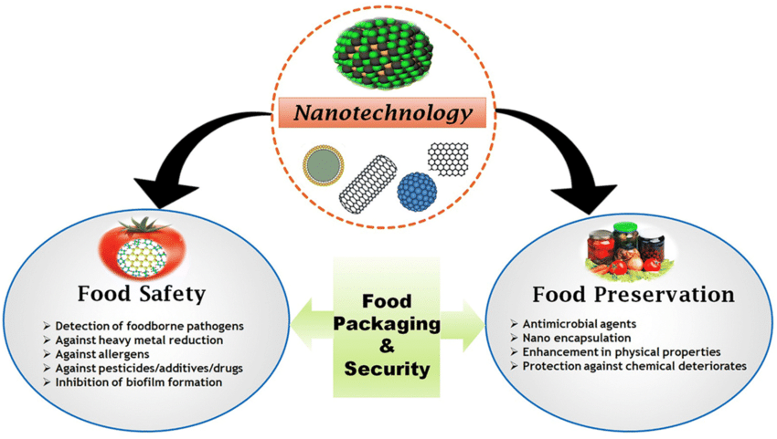***Figure: Applications of nanotechnology for food safety and preservation*

* + 1. **Environmental Remediation:**

Nanotechnology offers innovative and efficient solutions for environmental remediation by using nanomaterials to remove pollutants, clean up contaminated sites, and restore ecosystems. These materials exhibit unique properties such as high surface area, reactivity, and catalytic activity, making them highly effective for air, water, and soil remediation.

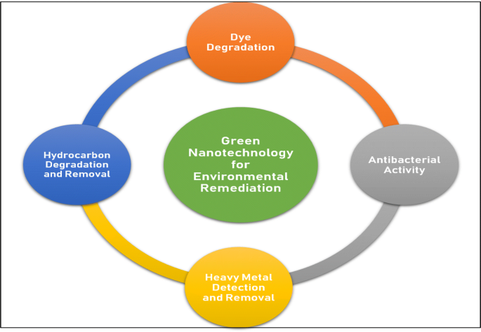

***Figure:*** *Green Nanotechnology for Environmental Remediation*

Key Applications of Nanotechnology in Environmental Remediation can be discussed as follow:**12**

* + Nanomaterials can remove heavy metals, organic pollutants, and pathogens from water sources.
  + **Carbon Nanotube (CNT) and Graphene Membranes:** Filter out salts, bacteria, and toxins efficiently.
  + Nanomaterials improve the removal of pollutants from contaminated soil, preventing groundwater contamination.
  + Bio nanocomposites Enhance soil microbial activity to naturally degrade pollutants.
  + **Platinum (Pt), Palladium (Pd), and Cerium Oxide (CeO₂) Nanoparticles:** Used in catalytic converters to break down NOx, CO, and hydrocarbons.
  + TiO₂-based coatings on buildings break down air pollutants using sunlight.
  + Nanotechnology enhances the breakdown of waste and supports sustainable recycling. This can be Used for biodegradable plastic decomposition and organic waste breakdown.
    1. **Healthcare:** Nanotechnology plays and crucial role in the field of healthcare and medical sciences.

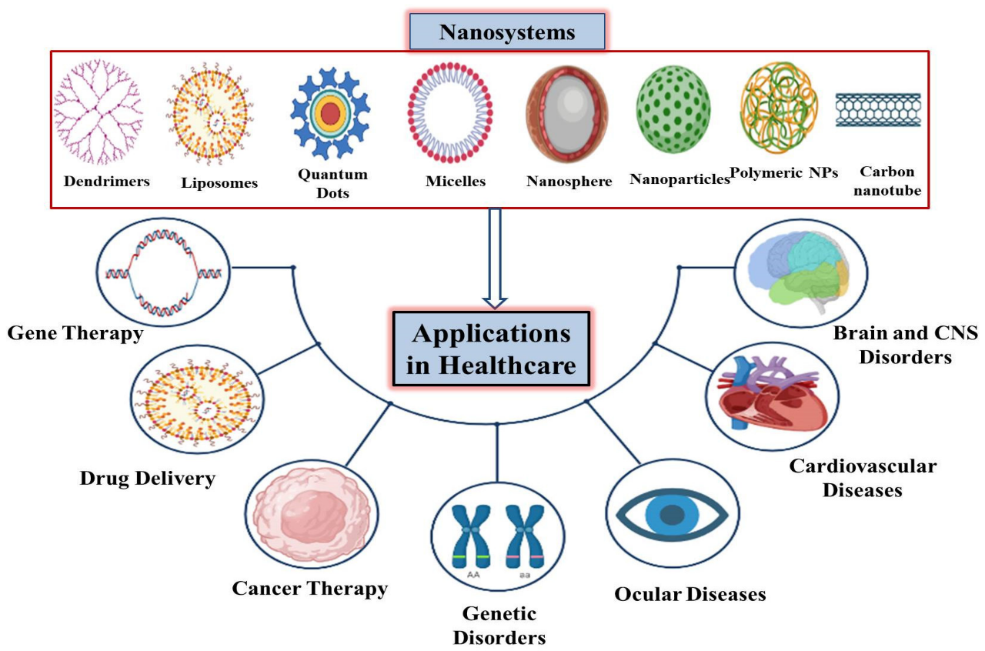

***Figure:*** *Applications of various nanosystems in allied healthcare sectors****37***

We can describe applications of nanomaterials and nanotechnology as follow:**38**

* Diagnostic sciences are now using nanodevices for early and rapid disease identification for further medical procedural recommendations. It also utilizes nanotechnology for the predisposition of disease at the cellular and molecular level to develop insights into treatment options. One of the profound applications includes nanoparticle-based diagnostic imaging, such as magnetic resonance imaging (MRI), computerized tomography (CT) scans, and positron emission tomography (PET) scans, making them more sensitive, accurate, and specific.
* Nanotechnology-enabled point of care diagnostic tests can quickly and accurately detect infectious diseases, cancers, and other illnesses, enabling timely treatment and prevention.
* Biosensors are yet another dimension of application in which nanotechnology has enabled the development of highly sensitive biosensors that can detect even low levels of biomolecules in bodily fluids such as blood and urine, facilitating early detection and disease management.
* Nanopore sequencing, is a novel technology that uses nanopores to detect the sequence of DNA or RNA molecules, allowing for rapid and accurate diagnosis of genetic disorders such as cancer and genetic diseases .
* The nanomedicine approach is being used to develop devices capable of working, responding, and modifying within the human body with the sole purpose of early diagnosis of any irregularities in the human body that could lead to toxicity or tumor development events.

**So**, overall by above explanations we can say that, nanomaterials have a wide range of applications in sustainable technologies and sustainable development and these applications make nanomaterials very important for human civilization. So we can say that nanotechnology can be a Greener Path for our Society and our Civilization.

**Conclusion:**

Nanoscience is the study and manipulation of matter at the nanoscale (1-100nm). Nanomaterials can be classified on the basis of dimensions, origin and their structural configuration. Nanomaterials are found both in nature and can also be synthesized in laboratory. Fullerene, quantum dots, nanowires dendrimers and liposomes are the some examples of nanomaterials. Nanomaterials have a wide range of applications in developing junctionless transistors, next generation computer chips, in medical science, manufacturing nanocatalysts, in energy production and making energy storage devices.

These novel materials can be synthesized by using methods like sol-gel method, physical vapour deposition method,solvothermal synthesis, gas phase condensation and precipitation methods. We can know about physical and chemical characteristics of these materials by using characterization techniques XRD, UV-Visible spectroscopy, Scanning Electron Microscopy, Atomic Force Microscopy and Magneto-Optical Kerr Effect (MOKE).

Nanotechnology offers promising solutions for sustainable technologies, addressing glbal challenges in areas like energy, water, food and healthcare with unique properties and enhanced capabilities. Its ability to manipulate materials at the nanoscale allows for the creation of solutions that are more efficient, less wasteful and environmentally friendly. In the context of achieving Sustainable Development Goals (SDGs), we can use nanotechnology in the development of renewable energy, food safety, medical sciences , in atmosphere remediation, water treatment and in solid waste management. So in this way we can say that by using nanoscience we can get *‘The Greener Path for Our Society and Civilization.’*

**References:**

1. Drexler KE (1986). [*Engines of Creation: The Coming Era of Nanotechnology*](https://archive.org/details/enginesofcreatio00drex). Doubleday. [ISBN](https://en.wikipedia.org/wiki/ISBN_(identifier)) [978-0-385-19973-5](https://en.wikipedia.org/wiki/Special:BookSources/978-0-385-19973-5). [OCLC](https://en.wikipedia.org/wiki/OCLC_(identifier)) [12752328](https://search.worldcat.org/oclc/12752328).
2. Drexler, Eric. ["There's Plenty of Room at the Bottom"](https://web.archive.org/web/20161226131619/http:/metamodern.com/2009/12/29/theres-plenty-of-room-at-the-bottom%E2%80%9D-feynman-1959/). Archived from [the original](http://metamodern.com/2009/12/29/theres-plenty-of-room-at-the-bottom%E2%80%9D-feynman-1959/) on 2016-12-26. Retrieved 2011-12-29.
3. [*Ford M*](https://en.wikipedia.org/w/index.php?title=Marin_Ford&action=edit&redlink=1) (2018). [*Rise of the Robots: Technology and the threat of a jobless future*](https://en.wikipedia.org/wiki/Rise_of_the_Robots). [*Basic Books*](https://en.wikipedia.org/wiki/Basic_Books). p. 242. [*ISBN*](https://en.wikipedia.org/wiki/ISBN_(identifier)) [*978-0-465-09753-1*](https://en.wikipedia.org/wiki/Special:BookSources/978-0-465-09753-1).
4. Berg J, Tymoczko JL, Stryer L (2002). ["Kinesin and Dynein Move Along Microtubules"](https://www.ncbi.nlm.nih.gov/books/NBK22572/). *Biochemistry. 5th Edition*.
5. Tawfik A. Saleh, [Environmental Technology & Innovation](https://www.sciencedirect.com/journal/environmental-technology-and-innovation)**,**[Volume 20](https://www.sciencedirect.com/journal/environmental-technology-and-innovation/vol/20/suppl/C), November 2020,101067

## **V.V.** Pokropivny, **V.V.** Skorokhod, [Materials Science and Engineering: C](https://www.sciencedirect.com/journal/materials-science-and-engineering-c) [Volume 27, Issues 5–8](https://www.sciencedirect.com/journal/materials-science-and-engineering-c/vol/27/issue/5), September 2007, Pages 990-993

1. N. Sumi, K.C. Chitra, [Aquatic Toxicology](https://www.sciencedirect.com/journal/aquatic-toxicology) [Volume 210](https://www.sciencedirect.com/journal/aquatic-toxicology/vol/210/suppl/C), May 2019, Pages 196-206
2. Djordjevic, Ivan (2012), ["Physical Implementations of Quantum Information Processing"](https://linkinghub.elsevier.com/retrieve/pii/B9780123854919000137), *Quantum Information Processing and Quantum Error Correction*, Elsevier, pp. 493–549,

## AminAleebrahim Dehkordi, Shirin Mollazadeh, Amirreza Talaie, Engineering PAMAM dendrimers for optimized drug delivery, [Nano Trends](https://www.sciencedirect.com/journal/nano-trends) [Volume 9](https://www.sciencedirect.com/journal/nano-trends/vol/9/suppl/C), March 2025, 100094

1. Lozhkomoev, A.S., Pervikov, A.V., Chumaevsky, A.V., Dvilis, E.S., Paygin, V.D., Khasanov, O.L., Lerner, M.I., 2019. Fabrication of Fe-Cu composites from electroexplosive bimetallic nanoparticles by spark plasma sintering. Vacuum 170, 108980.
2. Arian Nowbahari, Avisek Roy and Luca Marchetti; Junctionless Transistors: State-of-the-Art; Electronics 2020, 9(7), 1174.

## Shamshad Khan, Mu. Naushad , Adel Al-Gheethi; Engineered nanoparticles for removal of pollutants from wastewater; [Journal of Environmental Chemical Engineering](https://www.sciencedirect.com/journal/journal-of-environmental-chemical-engineering)[**Volume 9, Issue 5**](https://www.sciencedirect.com/journal/journal-of-environmental-chemical-engineering/vol/9/issue/5), **October 2021, 106160.**

## Mohsen Ghorbian, Mostafa Ghobaei-Arani ; [**Sensing and** Bio-Sensing Research](https://www.sciencedirect.com/journal/sensing-and-bio-sensing-research)[**Volume 47**](https://www.sciencedirect.com/journal/sensing-and-bio-sensing-research/vol/47/suppl/C), **February 2025, 100740.**

## Manojkumar Narasimhan, Muthukumaran Chandrasekaran,

## Sharmila Govindasamy; Heterogeneous nanocatalysts for sustainable biodiesel production; [Journal of Environmental Chemical Engineering](https://www.sciencedirect.com/journal/journal-of-environmental-chemical-engineering)[Volume 9, Issue 1](https://www.sciencedirect.com/journal/journal-of-environmental-chemical-engineering/vol/9/issue/1), February 2021, 104876**.**

1. Salar-García, M.J.; Ortiz-Martínez, V.M. Nanotechnology for Wastewater Treatment and Bioenergy Generation in Microbial Fuel Cells. In *Advanced Research in Nanosciences for Water Technology*; Springer: Cham, Switzerland, 2019; Volume 15, pp. 341–362.
2. R. Nagarajan, “Nanoparticles: Building Blocks for Nanotechnology,” in Nanoparticles: Synthesis, Stabilization, Passivation, and Functionalization, American Chemical Society, 2008, pp. 2-14.
3. Luka Noc, Ivan Jerman, in Solar Energy Materials and Solar Cells, 2022, 238:111625.
4. Ayush Kumar, Rajesh Kumar; Metal-organic Frameworks (MOFs) Nanocarriers , Biomedical Engineering, 2023, 2800, 020185.
5. Yunye Gao , Mingyuan Gao ; Two-dimensional multiferroics, Nanoscale, 2021, **13**, Pages 19324-19340.

## Amol Nande a, N. Thejo Kalyani b, Ashish Tiwari; [Functional Materials from Carbon, Inorganic, and Organic Sources](https://www.sciencedirect.com/book/9780323857888/functional-materials-from-carbon-inorganic-and-organic-sources) **Methods and Advances Woodhead Publishing Series in Electronic and Optical Materials 2023, Pages 1-19.**

1. Y.-L. Liu, H.-F. Yang, Y. Yang, Z.-M. Liu, G.-L. Shen, R.-Q. Yu, Thin Solid Films **497**, 355 (2006).
2. Aditi Saikia and Niranjan Karak: Biodegradable and biocompatible polymer nanocomposites, 2023, Pages 1-34.

# [Hamid Reza Ghorbani](https://www.researchgate.net/profile/Hamid-Ghorbani-3?_tp=eyJjb250ZXh0Ijp7ImZpcnN0UGFnZSI6InB1YmxpY2F0aW9uIiwicGFnZSI6InB1YmxpY2F0aW9uIn19), [Fedos Parsa Mehr](https://www.researchgate.net/scientific-contributions/Fedos-Parsa-Mehr-2080165851?_tp=eyJjb250ZXh0Ijp7ImZpcnN0UGFnZSI6InB1YmxpY2F0aW9uIiwicGFnZSI6InB1YmxpY2F0aW9uIn19), [Hossein Pazoki](https://www.researchgate.net/scientific-contributions/Hossein-Pazoki-2080151603?_tp=eyJjb250ZXh0Ijp7ImZpcnN0UGFnZSI6InB1YmxpY2F0aW9uIiwicGFnZSI6InB1YmxpY2F0aW9uIn19); Synthesis of ZnO Nanoparticles by Precipitation Method June 2015 [Oriental Journal Of Chemistry](https://www.researchgate.net/journal/Oriental-Journal-Of-Chemistry-2231-5039?_tp=eyJjb250ZXh0Ijp7ImZpcnN0UGFnZSI6InB1YmxpY2F0aW9uIiwicGFnZSI6InB1YmxpY2F0aW9uIn19) 31(2):1219-1221.

1. Takacs, Laszlo (January 2002). "Self-sustaining reactions induced by ball milling". Progress in Materials Science. 47 (4): *355–*414.
2. Hammond, C. *The Basics of Crystallography and Diffraction*, 4th ed.; Oxford University Press: Oxford, UK, **2015**.
3. Skoog, Douglas A.; Holler, F. James; Crouch, Stanley R. (2007). [Principles of Instrumental Analysis](https://archive.org/details/principlesinstru00dasc) (6th ed.). Belmont, CA: Thomson Brooks/Cole. pp. [169](https://archive.org/details/principlesinstru00dasc/page/n182)–173.
4. Nicole Gleichmann, Electron Microscopy Techniques, Analysis and Separation, 2021, pages 568-576.
5. Yuves F. Dufrene, Toshio Ando, Imaging modes of atomic force microscoy, Nature Nanotechnology 12, 2017, pages 295-307.
6. Foner, Simon. “Versatile and Sensitive Vibrating-Sample Magnetometer”. Rev. Sci. Instrum. **30** (7) 2008 : 548-557.
7. Dyakov, S.A.; Klompmaker, L.; Spitzer, F.; Yalcin, E.; Akimov, I.; Yavsin, D.A.; Pavlov, S.I.; Pevtsov, A.B.; Verbin, S.Y.; Tikhodeev, S.G.; et al. Wide band enhancement of transverse magneto-optic Kerr effect in magnetite-based plasmonic crystals. *Phys. Rev. B* **2019**, *100*, 214411.

# [V. Buckin](https://www.semanticscholar.org/author/V.-Buckin/144356353), [C. Smyth](https://www.semanticscholar.org/author/C.-Smyth/2081512512), [A. Alting](https://www.semanticscholar.org/author/A.-Alting/3389432), [R. W. Visschers](https://www.semanticscholar.org/author/R.-W.-Visschers/7992118); Ultrasonic spectroscopy for material analysis. Recent advances; 2003.

1. Zhao, Yuliang; Bai, Chunli; Brinker, C. Jeffrey; Nano as a Rosetta Stone: The Global Roles and Opportunities for Nanoscience and Nanotechnology; *ACS Nano (2019), 13 (10), 10853-10855CODEN: ANCAC3; ISSN:1936-0851.*
2. H. Yuan, Q. Jiao, J. Liu, X. Liu, Y. Li, D. Shi, Q. Wu, Y. Zhao, H. Li, Facile synthesis of Co0.85Se nanotubes/reduced graphene oxide nanocomposite as Pt-free counter electrode with enhanced electrocatalytic performance in dye-sensitized solar cells, Carbon 122 (2017) 381–388.
3. Y. Wang, X. Chen, H. Zhang, G. Xia, D. Sun, and X. Yu,“Heterostructures built in metal hydrides for advanced hydrogen storage reversibility,” Advanced Materials, vol. 32, no. 31, article 2002647, 2020.

## **Muhammad Naeem 1, Muhammad Imran 1, Shoomaila Latif;** [**Nanomaterials in Biomass Conversion**](https://www.sciencedirect.com/book/9780443135002/nanomaterials-in-biomass-conversion)**; 2024, Pages 189-214.**

1. Afshin Rashid. (2024). Review of: "Nano supercapacitors (supercapacitors or electrochemical nanocapacitors)".

## M.P. Ajith a, M Aswathi b, Eepsita Priyadarshini a, Paulraj Rajamani; Recent innovations of nanotechnology in water treatment; [Bioresource Technology](https://www.sciencedirect.com/journal/bioresource-technology)[**Volume 342**](https://www.sciencedirect.com/journal/bioresource-technology/vol/342/suppl/C), December 2021, 126000.

1. Dreaden, E.C.; Alkilany, A.M.; Huang, X.; Murphy, C.J.; El-Sayed, M.A. The golden age: Gold nanoparticles for biomedicine. Chem. Soc. Rev. **2012**, 41, 2740–2779.